Check out our website!
www.wingra.weebly.com
*Here you will find websites and apps to practice Spanish as well as unit updates and articles related to how you can help your child learn more Spanish.

Looking to buy books in Spanish?
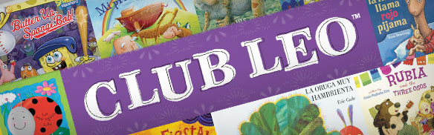
Scholastic offers a variety of young adult and children’s literature in Spanish (Club Leo). If you are interested in ordering books, please come to the Spanish room (207) for an order form. Students can also check books out from the Spanish classroom or the public library.

Interested in helping in the Spanish room?
Please let me know if you are interested in sitting in on Spanish classes to help facilitate group work or coming on field trips. A few of the trips that I have in mind are going to various restaurants, Centro Hispano, UW-International Learning Community and a Latin dance show.

Upcoming event
On Saturday, September 14th there is a festival for Mexican Independence day at Warner Park between 11am and 10pm. There will be authentic food, dancing and fun activities for children. Please consider attending.

ePals in the Sky
Sky students will soon be given their information to participate in an e-mail exchange program with a school in Argentina (Instituto Paula Albarracin de Sarmiento). This should be a great opportunity for our Sky students to expand upon their written Spanish skills. We hope to also be able to Skype with their English class at some point.

Five Ways you Can Support Spanish Learning

1. Board Games: Play your favorite board and card games in Spanish by saying colors, numbers, alphabet etc. in Spanish. If you would like some resources with Spanish words on them just e-mail me at cristina@wingraschool.org and I can e-mail them to you. We have Uno, Go Fish, Dominos, Scrabble, Twister, Guess Who, Bingo, Apples to Apples in Spanish, Zingo and Chess in the Spanish room.

2. Label your home or a room: Make it a game to see who can label the most items in your home. You may want to use www.wordreference.com to look up words.

3. Look at books, listen to the radio, get apps or watch TV in Spanish:
There are many resources to connect you to the Spanish-speaking world through technology. Some resources are listed on the website www.wingra.weebly.com. Listen to the language, enjoy how it sounds and build comprehension based on context. If you feel confident, reading out loud can be a great way to practice pronunciation. You can use www.wordreference.com to listen to pronunciation of words.

4. Explore Madison! Here are some places that you could consider visiting.
El Bolillo (bakery) Caracas Empanadas (food cart)
La Concha (bakery) Pollo Inka (restaurant)
Taquería Guadalajara Centro Hispano (community center)
Tienda Los Gemelos (Restaurant) Jolly Bob’s (restaurant)
El Mercadito
Mercado Marimar (Grocery store)
Santa Maria Grocery (Grocery store)
Inka Heritage (restaurant)
The Icon (restaurant)
La Movida (radio- http://www.lamovidaradio.com/)

5. Reinforce Basic Vocabulary at Home:
Use Spanish at home with one another. Try your best! Let your children see you as a Spanish learner as well.
• Hello! = ¡Hola! -- pronounced "oh-lah"
• Yes = Sí -- pronounced "see"
• No = No -- pronounced "no"
• Thank you! = ¡Gracias! -- pronounced "grah-thee-ahs"
• Please = Por favor -- pronounced "pohr fah-bohr"
See you later! = ¡Hasta luego! -- pronounced "ahs-tah loo-eh-goh"

